**Current Technical Papers and Others**

***International Journals***

1. Ram Rathan Lal, B. and **Mandal, J. N.** (2013). “Study of cellular reinforced fly ash under triaxial loading conditions.” *International Journal of Geotechnical Engineering*, 7(1), 86-99.
2. Kandolkar, S. S. and **Mandal, J. N.** (2013). “Behaviour of Reinforced Mine Waste Model Walls under Uniformly Distributed Loading.” *The Electronic Journal of Geotechnical Engineering*, Vol. 18, Bund G, 1351-1365.
3. Ram Rathan Lal, B and **Mandal, J. N.** (2013). “Behaviour of Cellular Reinforced Fly ash walls under strip loading.” *Journal of hazardous Toxic and Radioactive Waste, ASCE,* (Accepted for Publication)
4. Padade, A. H. and **Mandal, J. N.** (2013). “Interface strength behavior of expanded polystyrene (EPS) geofoam*.” International Journal of Geotechnical Engineering,* Manuscript No: IJGE 488, (Accepted for publication in January 2014 issue)
5. Asha, B.S. and **Mandal, J. N.** (2012). “Absorption and discharge capacity tests on natural prefabricated vertical drains.”*Geosynthetic International,* 19(4), 263-271.
6. Ram Rathan Lal, B. and **Mandal, J. N.** (2012) “Feasibility Study on Fly ash as Backfill Material in Cellular Reinforced Walls.” *The* *Electronic Journal of Geotechnical Engineering*, Vol.17 , Bund. J, 1637-1658.
7. Asha, B. S. and **Mandal, J. N.** (2012). “Filtration tests on marine clay – jute geotextile filter sheath systems.” *The* *Electronic Journal of Geotechnical Engineering*, Vol.17, Bund. R, 2659-2672.
8. Padade, A. H. and **Mandal, J. N.** (2012) “Behavior of expanded polystyrene (EPS) geofoam under triaxial loading condition.” *The Electronic Journal of Geotechnical Engineering*, Vol. 17, Bund S, 2543-2553.
9. Kandolkar, S. S. and **Mandal, J. N.** (2012). “Behaviour of Mine Waste as Reinforced Soil,” *International Journal of Research in Engineering and Technology (IJRET)*, Vol. 1(2), pp. 82-89.
10. Dutta, S. and **Mandal, J. N.** (2013). “Behavior of Bamboo Geocells under Compression Loading Condition,” *International Journal of Civil Engineering (IJCE)*, 2(3), 123-128.
11. Asha, B. S. and **Mandal, J. N.** “Laboratory performance tests on natural PVDs in marine clay.” *Ground Improvement,* (Resubmitted after review: 20th May, 2013).
12. Ram Rathan Lal, B and **Mandal, J. N.** “Behaviour of Cellular Reinforced Fly ash walls under uniformly distributed loading.” *International Journal of Geotechnical and Geological Engineering,* Manuscript No: GEGE-13-00051 (Submitted and under review).
13. Ram Rathan Lal, B and **Mandal, J. N.** “Model Tests on Geocell Walls under Strip loading.” *Geotechnical Testing Journal. ASTM,* Manuscript No: GTJ-2013-0094, (Submitted and under re-review).
14. Padade, A. H. and **Mandal J. N.** “Expanded polystyrene (EPS) based geomaterial.” *Geosynthetics International,* Manuscript No: GI 689, (Resubmitted after review: 12th June, 2013).
15. Padade, A. H. and **Mandal, J. N.** (2013). “Expanded Polystyrene (EPS) based cellular reinforcement.” *Journal of Materials in Civil Engineering, ASCE,* Manuscript No: MTENG 2225, (Communicated and under review)

***International Conferences***

1. Lahoti, A., Jain, P., Bajoria, K. M. and **Mandal, J. N.** (2012) “Design of 300 m high artificial mountain using geosynthetics.” *Geo congress -2012*, I*nternational Conference State of the Art and Practice in Geotechnical Engineering* , 25-29th March 2012, ASCE, Oakland, CA, USA, 489-496.
2. Asha, B. S., Ram Rathan Lal, B., Padade, A. H., Mandal, T. and **Mandal J. N.** (2012) “Emerging trends in ground improvement techniques.” I*nternational Conference State of the Art and Practice in Geotechnical Engineering, Geo congress -2012*, ASCE, 25-29th March 2012, Oakland, CA, USA, 594-603.
3. Das, N. K and **Mandal, J. N.** (2012) “Experimental, environmental and finite element analysis of the woven jute geotextile tube.” *International Conference Second Pan American Congress Geosynthetics – GeoAmericas 2012*, 1-4th May 2012, Lima, Peru, 0947-0956.
4. Ram Rathan Lal, B. and **Mandal, J. N.** (2012) “Experimental and finite element study of cellular reinforced fly ash under triaxial loading conditions.” *International Conference Second Pan American Congress Geosynthetics – GeoAmericas 2012*, 1-4th May 2012, Lima, Peru, 0759-0768.
5. Padade, A. H. and **Mandal, J. N.** (2012). “Feasibility studies on expanded polystyrene (EPS) geofoam.” *International conference on ground improvement,* 30th Oct-2nd November 2012, Wollongong, Australia, Vol. 2, 903-909.
6. Adhana, S, Ram Rathan Lal, B and **Mandal, J. N.** (2012) “Study on reinforced fly ash steep slopes.” *5th European geosynthetics congress – EUROGEO 5*, 16-19th September 2012, Valencia, Spain, Vol. 4, 8-12.
7. Chaudhury, N. N., Dutta, S. and **Mandal, J. N.** (2012) “Modified Design methods for flexible airfield pavement using geosynthetic reinforcement.” *5th European geosynthetics congress – EUROGEO 5*, 16-19th September 2012, Valencia, Spain, Vol. 4, 99-103.
8. Padade, A. H. and **Mandal, J. N.** (2012) “Direct shear test expanded polystyrene (EPS) geofoam.” *5th European geosynthetics congress, EUROGEO 5*, 16-19th September 2012, Valencia, Spain, Vol. 4, 624-627.
9. Padade, A. H., Paul, M., Dutta, S. and **Mandal, J. N.** (2012). “Study on Improvement of Pavement Using Fibers.” *10th International Conference on Transportation Planning and Implementations Methodologies for Developing Countries, TPMDC- 2012*, 12-14 December, 2012, Mumbai, India, Paper: 227, 1-6.
10. Dutta, S., Padade, A. H. and **Mandal, J. N.** (2012) “Experimental Study on Natural Bamboo Geogrid Encased Stone Column.” *5th Asian Regional Conference on Geosynthetics, Geosynthetics Asia- 2012*, 13 to 15 December 2012, Bangkok, Thailand, 417-426.
11. Asha, B. S. and **Mandal, J. N.** (2013). "Long Term Hydraulic Conductivity Ratio Tests on Jute Geotextile Filter of Natural Prefabricated Vertical Drains." *18th Southeast Asian Geotechnical & Inaugural AGSSEA Conference*, *SEAGC-2013*, May 29-31, 2013, Singapore, pp.183-188.
12. Padade, A. H. and **Mandal, J. N.** (2013). "Compressive Strength and Flammability Characteristics of Expanded Polystyrene (EPS) Geofoam." *18th Southeast Asian Geotechnical & Inaugural AGSSEA Conference*, *SEAGC-2013*, May 29-31, 2013, Singapore,

pp.373-378.

***National Conferences***

1. Dutta, S., Asha, B. S., Ram Rathan Lal, B., Padade, A. H. and **Mandal J. N.** (2012) “Novel Techniques for Ground Improvement in India.” *Keynote lecture - Proceedings of First National Conference in the Emerging Vistas of Technology in 21st Century – NCEVT’12,* 14-15th April, 2012, Ahmedbad, India, 103-114.
2. Padade, A. H. and **Mandal, J.N.** (2012) “Expanded Polystyrene (EPS) Geofoam: A Material Behavior.” *Proceedings of Indian Geotechnical Conference- IGC -2012*, 13-15th Dec. 2012, New Delhi, India, Vol. 1, 157-160.
3. Dutta, S. and **Mandal, J.N.** (2012) “Behavior of Soft Soil Reinforced with Encased Stone Columns.” *Proceedings of Indian Geotechnical Conference- IGC -2012*, 13-15th Dec. 2012, New Delhi, India, Vol. 1, 420-423.

***Editorial Board Members***

1. Editorial Board Member Of Journal Of Civil Engineering (Jce) Under International Academy Of Science And Technology
2. Editorial Board Member of The ‘International Journal of Structural and Civil Engineering Research’ (IJSCER)
3. Editorial Board Member of International Journal of Research in Engineering and Technology (IJRET)

***Invited***

***invited for presentation of the papers in various institutes/universities/conferences in u.s.a., canada, u.k., germany, russia, netherlands, france, switzerland, taly ,australia,bangkok,south korea, japan,Thailand and singapore etc***

***.invited for key note speakers and chair and co-chair for many international /national conferences in india and abroad.***

Many Ph.D and M.Tech students (48) have completed their thesis under my supervision.

**Current Research Scholars**

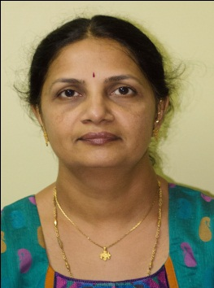

Name: **Asha B. S.**

Roll No: **09404802**

Year of Joining: **Spring 2010**

Year of Completion: **June 2013**

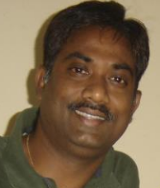

Name: **B. Ram Rathan Lal**

Roll No: **10404303**

Year of Joining: **Autumn 2010**



Name: **Amit Harihar Padade**

Roll No: **10404006**

Year of Joining: **Autumn 2010**



Name: **Sushovan Dutta**

Roll No: **10304024**

Year of Joining: **Autumn 2010**



Name: **Sumitra Khandolkar**

Roll No: **10404806**

Year of Joining: **Autumn 2011**



Name: **Patki Mrunal Avinash**

Roll No: **124040006**

Year of Joining: **Autumn 2012**

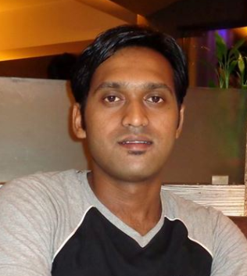

Name: **Maheboobsab B. Nadaf**

Roll No: **124040007**

Year of Joining: **Autumn 2012**

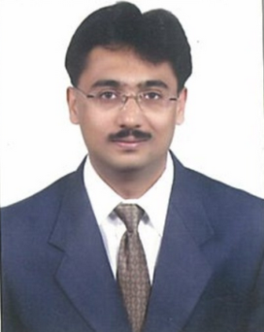

Name: **Prasanna Kulkarni**

Roll No: **124047002**

Year of Joining: **Autumn 2012**



Name: **Dulal Chandra Saha**

Roll No: **124048006**

Year of Joining: **Spring 2013**

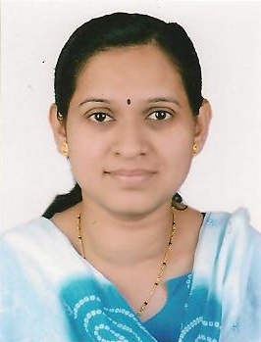

Name: **Bhadrike Jagruti Shantaram**

Roll No: **124048008**

Year of Joining: **Spring 2013**

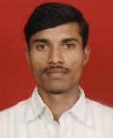

Name: **Sariput Madhavrao Nawghare**

Roll No: **134043001**

Year of Joining: **Autumn 2013**

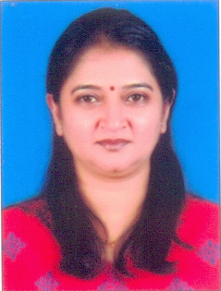

Name: **Usha Prabhakar Kadam**

Roll No: **134048006**

Year of Joining: **Autumn 2013**



Name: **Abebe Worku**

Roll No: **134042002**

Year of Joining: **Autumn 2013**